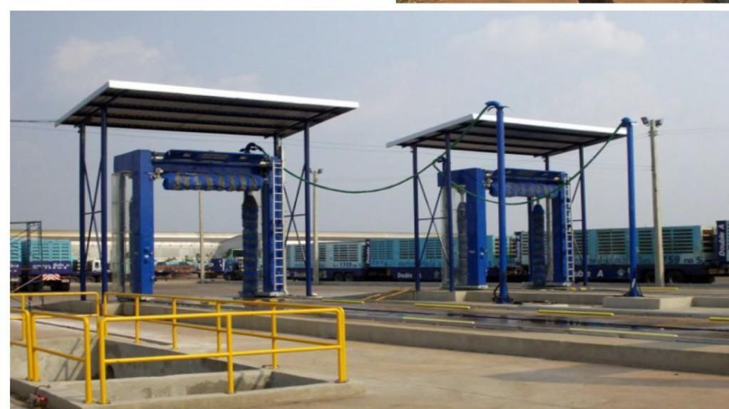**Tiba Swiss International**

**شركه طيبه سويس العالميه**

**Car washing Machine Model**

**T.S.I Main Products**

**General Contractor Company**

**Schlosslistrasse 2**

**2504 Bie/Bienne**

**Tel . +41763435938**

**info@tibaswiss.ch**

**Benefits of automatic washingفوائد الغسيل الآلي**

**Maintain the car تحافظ علي السيارة**

**More clean for the clean نظافه اكثر للسيارة**

**Save time only five minutesتوفير الوقت فقد خمس دقائق**

**Car rust preventionالوقايه من الصدأ للسيارة**

**Friendly and maintain proofصديقه ومحافظه علي البيئه**

**of ease of payment and useسهوله الدفع والاستخدام**

**Laundry at any time الغسيل في اي وقت**

**Technical Data T.S.I 204 معلومات تنبيه عن**

|  |  |  |  |
| --- | --- | --- | --- |
| **No.** | **Function Descriptions** | **Brand Details** | **Remarks** |
| **(1)**  **(2)**  **(3)**  **(4)**  **(5)** | **Water Protection Level is IP67**  It can display a variety of car wash modes, parking indication, fault display, status display, etc.  Accurately sense the body position,  determine the cleaning range  Precisely control the amount of foam, colorful leave-in solution, and coating water wax  1.Thickness up to 4mm,  2.Q235 international standard,  3.salt spray test grade ten  4mm,Q235 | **Taiwan Delta servo motor**  **Sino-Intlund waterproof air-drying motor**  **Sino-Intlund waterproof air-drying motor**  **Taiwan Delta servo drive system**  **Taiwan Delta**  **LCD screen**  **Pepperl+Fuchs Alemania**  **P+F ultrasónico**  **Pepperl+Fuchs P+F Photoelectric Sensor**  **Japan Omron Relay**  **French Schneider**  **Contactor**  **taly New Dotz**  **Liquid Dosing Pump**  **Hot dipped galvanized**  **steel frame**  **High strength**  **416 stainless steel**  **nozzle** |  |
| **Second** | **Total project value (USD)** |  |  |
| **Third**  **(1)**  **1.1**  **1.2**  **1.3**  **1.4**  **1.5**  **1.6**  **1.7**  **1.8**  **(2)**  **2.1**  **2.2**  **2.3**  **2.4**  **2.5**  **2.6**  **2.7**  **2.8**  **2.9**  **2.2.1**  **2.2.2**  **2.2.3**  **2.2.4** | **HP-260 Type (Touchless 360 car wash)**  **Descriptions / Touchless 360 car wash**  **1.Intelligent unmanned systems**  **2. Smart 360 technology.**    **3. Intelligent chemical mixing system.**  **4. Innovative suspension system non-resistance rails**  **5. Unique embedded fast drying system**  **6. Digital voice security alarm system**  **7. Faulty self-checking system**  **8. One key anti-frozen system**  **Specifications:**  **Model**  Machine dimensions  INSTALLATION SPACE  SUPPLY STATION  Main power  Total power  Water pressure  Air supply  Vehicle type  Wash size  Wash speed  Power consumption  chemicals consumption  water consumption | **HP-260 (STANDARD)**  **LXWXH=3300mm*1100mm*1000mm**  **LXWXH=8180mm*3680mm*3500mm**  **LXWXH=2500mm*1600mm*2000mm**  **3 Phase 380 V 50HZ**  **Max:18.5kw;max working:18.5kw**  **70-120Bar**    **car/SUV/Coatch within 10 seats**  **LXWXH=2300mm*2500mm*2050mm**  **Quick wash:3'12" , Premium wash :5'12"**  **0.65kwh**  **7ml/12ml**  **165L** | **Germany pinfl**  **Japan NSK**  **Germany PEPPERL+FUCHS**  **France schneider**  **Taiwan Delta**  **Taiwan Delta**  **Germany PEPPERL+FUCHS** |

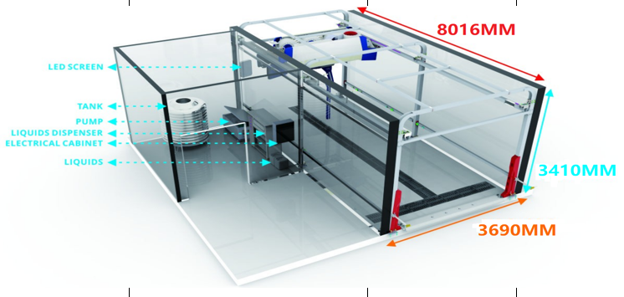

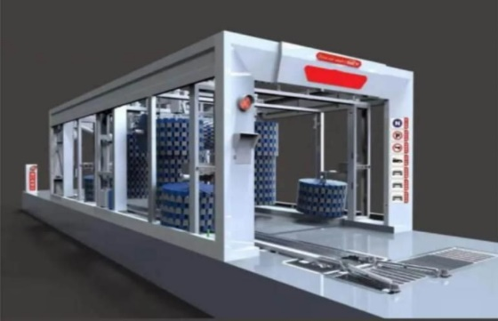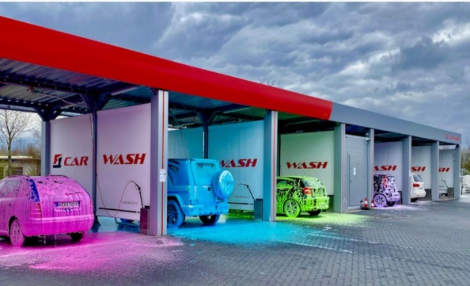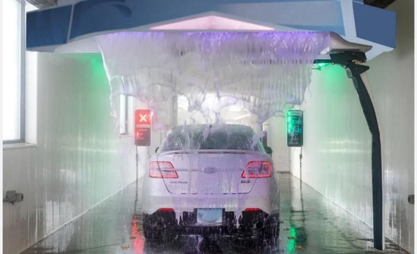

**Taiba Swiss International General شركه طيبه سويس العالميه**

**Trading and Contracting Company للتجاره العامه والمقاولات**

**Schlosslistrasse 2**

**2504 Bie/Bienne**

**Tel . +41763435938**

**info@tibaswiss.ch**